Unit 1 The Living World AP Exam Review
Predator Prey
1) Define Predator.
2) Define Prey.
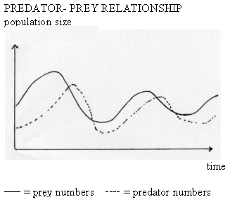
3) Describe the trends from observations of the figure to the left:

Symbioses
4) Define Symbiosis.
5) Fill in the chart below on the different types of symbioses.
Symbiosis Type | Species 1 Interaction (Beneficial, Harmful, or Neutral) | Species 2 Interaction  (Beneficial, Harmful, or Neutral) | Give a Real World Example

Competition and Resource Partitioning
6) What is competition?
7) How does competition sometimes lead to resource partitioning?
8) Compare interspecific to intraspecific competition.
Terrestrial Biomes
9) Define the term biodiversity.
10) Define the term biome.
11) Sketch and/or label the following on the map of the world below:
  - the equator
  - the tropic of Cancer and the tropic of Capricorn
  - the Mid-Atlantic Ridge
  - the location of suppressed upwelling characteristic of the occurrence of El Niño
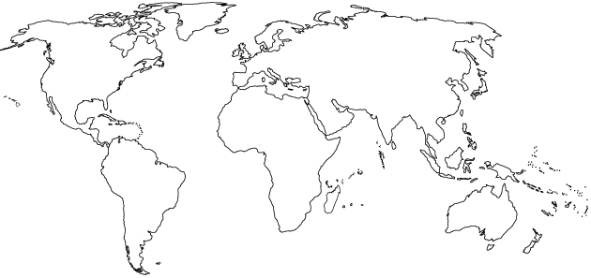
  - the location of China, India, Ethiopia, Brazil, Bangladesh, and Fremont

12) Fill in the table below about the different terrestrial biomes of the world.
Type of Biome | Typical Location | Typical Climate | Characteristic adaptations for survival
Tropical Rain Forest |  |  | Plants –  Animals –
Temperate Deciduous Forest |  |  | Plants –  Animals –
Taiga (Boreal) Forest |  |  | Plants –  Animals –
Tropical Grasslands (Savanna) |  |  | Plants –  Animals –
Temperate Grassland (Prairie) |  |  | Plants –  Animals –
Tundra  (Cold Grassland) |  |  | Plants –  Animals –
Desert |  |  | Plants –  Animals –

13) For each of the following biomes, identify a specific country in which each biome occurs in relative abundance:
Taiga Desert
Tropical rainforest Temperate grassland
Tropical grassland Coral reef
Temperate deciduous forest Tundra

Aquatic Biomes
14) Fill in the table below about the different aquatic biomes of the world.
Type of Biome | Typical Location | Typical Climate | Characteristic adaptations for survival
Coral Reef |  |  | Plants –  Animals –
Open Ocean |  |  | Plants –  Animals –
Kelp Forest |  |  | Plants –  Animals –
Estuary/Wetland |  |  | Plants –  Animals –

Biogeochemical Cycles: Carbon Cycle, Phosphorus, Nitrogen and Water Cycles
15) Complete the following table for these biogeochemical cycles:
Trait | Carbon | Nitrogen | Phosphorus | Water
Importance to life
Largest reservoir
Methods of transport
Cycle duration (long/short)

Detailed Nitrogen Cycle
16) Identify the characteristic process associated with each of the following.
Nitrification:
Denitrification:
Assimilation:
Nitrogen Fixation:
Ammonification:
Food Chains
17) Identify three examples of biotic components of an ecosystem and three examples of abiotic components of an ecosystem.
(1) (1)
Biotic: (2) Abiotic: (2)
(3) _____________________ (3) _________________________
18) Diagram a simple food chain in the space below. Label the trophic levels and illustrate the Rule of 10 with each trophic level. Start with 1,000,000 kCal in the primary producer level.

19) What happens when a predator is removed from the food chain or web?
1st and 2nd Law of Thermodynamics
20) Define the First Law of Thermodynamics
-Example
21) Define the Second Law of Thermodynamics
-Example

Gross Primary Productivity and Net Primary Productivity
23) Define GPP
24) Define NPP
25) What biomes have high NPP? Low NPP? Why?

GPP and NPP Math
26) Perform the following calculation. Show all of your work. If the grasses on a 100-hectare area of grassland grow at an average rate of 1 cm/day, the average volume of grass that is added to the grassland each day is ____________ m³. If the density of the grasses that grow in the grassland averages 400 kg/m³, the net primary productivity is approximately _____________ g/day or _____________ g/year. 1 hectare = 10,000 m²
Show work:

Sample FRQ’s
27) Biogeochemical cycles describe the movement of certain elements (typically bound with other elements in compounds) through Earth’s atmosphere, hydrosphere, biosphere, and lithosphere. These elements and their compounds are necessary components of all life, and because they cycle, they can be used repeatedly by new generations of organisms. Each biogeochemical cycle has different pathways with various reservoirs (sources and sinks) where elements may reside for days or millions of years.
(a) The atmosphere is one important carbon reservoir.
(i) Describe a biological process by which carbon is removed from the atmosphere and converted to organic molecules.
(ii) Describe a biological process by which carbon is converted from organic molecules to a gas and returned to the atmosphere.
(b) Oceans and terrestrial systems are also important carbon reservoirs.
(i) Explain how atmospheric carbon is incorporated into two oceanic sinks.
(ii) Identify one terrestrial sink, other than fossil fuels, that stores carbon for thousands to millions of years.
(c) The burning of fossil fuels has been shown to increase the concentration of carbon in the atmosphere. Discuss TWO other human activities that increase the concentration of carbon in the atmosphere.
(d) Identify an environmental problem that results from elevated atmospheric carbon concentrations. Discuss one consequence of the problem you identified.
(e) Phosphorus is another element important to all organisms.
i) Describe one major way in which the phosphorus cycle differs from the carbon cycle.
ii) Identify one reason that phosphorus is necessary for organisms.

28) After reading the following excerpt from an article about the interrelationships among organisms in an oak forest, answer parts (a), (b), and (c), which follow.
Chain Reactions Linking Acorns to Gypsy Moth Outbreaks and Lyme Disease Risk Oak trees (Quercus spp.) produce large autumnal acorn crops every two to five years, and produce few or no acorns during intervening years. Acorns are a critical food for white-footed mice (Peromyscus leucopus). Mice are important predators of the pupal stage of the gypsy moth (Lymantria dispar). This introduced insect periodically undergoes outbreaks that defoliate millions of hectares of oak forests, decreasing tree growth, survival, and acorn crop production. An abundance of acorns provides food for white-tailed deer (Odocoileus virginianus). Mice and deer are the primary hosts of the black-legged tick (Ixodes scapularis), which carries Lyme disease.
(a) In the space provided below, diagram a food web based on the interrelationships of the organisms identified in the excerpt.
(b) Design a controlled experiment that tests the relationship between acorn production and gypsy moth population. Include the hypothesis that the experiment tests.
(c) Briefly describe a strategy that uses integrated pest management for the control of the black-legged tick population.

29) Wetlands were once considered to be wastelands. Over 50 percent of the United States original wetlands have been destroyed.
(a) Describe TWO characteristics that are used by scientists to define an area as a wetland.
(b) Wetlands are highly productive ecosystems with complex food webs.
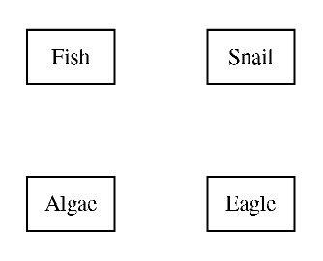
(i) Complete the diagram of the wetland food web to the right by drawing arrows that show the direction of energy flow.

(ii) Explain why it takes many hectares of wetland to support a pair of eagles.
(c) Describe TWO economic benefits (other than those related to water quality) that wetlands provide.
(d) Describe one specific human activity that degrades wetlands.

Modified by A. Willis from David Hong’s AP Environmental Science Review Packets (Diamond Bar HS). FRQ’s are College Board Released.
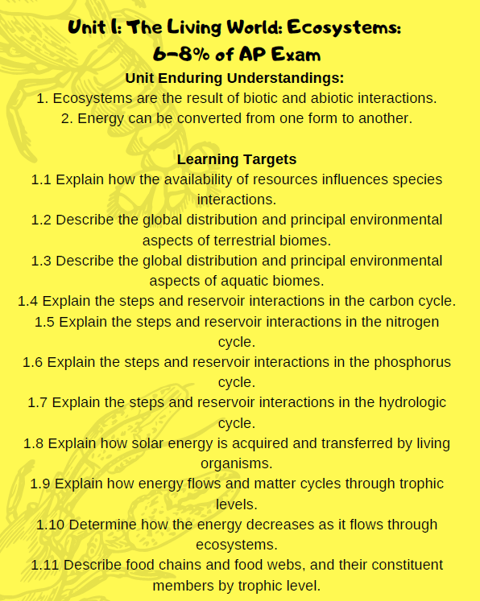
Unit 1 The Living World Review Videos
Mr. Andersen, Bozeman Biology
007 - Ecosystem Ecology
008 - Energy Flow in Ecosystems
009 - Ecosystem Diversity
010 - Natural Ecosystem Change
011 - Biogeochemical Cycles

Amoeba Sisters
Carbon and Nitrogen Cycle: https://www.youtube.com/watch?v=NHqEthRCqQ4
Ecological Relationships: https://www.youtube.com/watch?v=rNjPI84sApQ

Crash Course

Population Ecology - Crash Course Biology #2: https://www.youtube.com/watch?v=RBOsqmBQBQk&list=PL8dPuuaLjXtNdTKZkV_GiIYXpV9w4WxbX&index=2
Community Ecology: Feel the Love Crash Course Ecology #4 https://www.youtube.com/watch?v=GxE1SSqbSn4&list=PL8dPuuaLjXtNdTKZkV_GiIYXpV9w4WxbX&index=4
Community Ecology II: Predators Crash Course Ecology #5: https://www.youtube.com/watch?v=mFDiiSqGB7M&list=PL8dPuuaLjXtNdTKZkV_GiIYXpV9w4WxbX&index=5
Ecological Succession: Change is Good Crash Course Ecology #6: https://www.youtube.com/watch?v=jZKIHe2LDP8&list=PL8dPuuaLjXtNdTKZkV_GiIYXpV9w4WxbX&index=6
Ecosystem Ecology: Links in the Chain Crash Course Ecology #7: https://www.youtube.com/watch?v=v6ubvEJ3KGM&list=PL8dPuuaLjXtNdTKZkV_GiIYXpV9w4WxbX&index=7
The Hydrologic and Carbon Cycles: Always Recycle Crash Course Ecology #8: https://www.youtube.com/watch?v=2D7hZpIYlCA&list=PL8dPuuaLjXtNdTKZkV_GiIYXpV9w4WxbX&index=8
Nitrogen and Phosphorus Cycles: Always Recycle Part Two Crash Course Ecology #9: https://www.youtube.com/watch?v=leHy-Y_8nRs&list=PL8dPuuaLjXtNdTKZkV_GiIYXpV9w4WxbX&index=9
HHMI BioInteractive
Some Animals are More Equal Than Others: Trophic Cascades https://www.youtube.com/watch?v=hRGg5it5FMI
Khan Academy
Ecology Introduction: https://www.youtube.com/watch?v=OfV3VNgjpvw&list=PLbjyLFA2XFZyvLJTz-oWEUURQtwnf32eP
Ecosystems and Biomes: https://www.youtube.com/watch?v=A495e31cDdE&list=PLbjyLFA2XFZyvLJTz-oWEUURQtwnf32eP&index=2
Flow of Energy and Matter Through Ecosystems: https://www.youtube.com/watch?v=TitrRpMUt0I&list=PLbjyLFA2XFZyvLJTz-oWEUURQtwnf32eP&index=3
Interactions Between Populations: https://www.youtube.com/watch?v=q2zdiLn3gSE&list=PLbjyLFA2XFZyvLJTz-oWEUURQtwnf32eP&index=4
The Water Cycle: https://www.youtube.com/watch?v=jFjI6y46QRk&list=PLbjyLFA2XFZyvLJTz-oWEUURQtwnf32eP&index=5
Organism Life History and Fecundity: https://www.youtube.com/watch?v=mAdUjImDx58&list=PLbjyLFA2XFZyvLJTz-oWEUURQtwnf32eP&index=6
Nitrogen Cycle: https://www.youtube.com/watch?v=DsCMYyQ0NWU&list=PLbjyLFA2XFZyvLJTz-oWEUURQtwnf32eP&index=7
Biogeochemical Cycles: https://www.youtube.com/watch?v=ccWUDlKC3dE&list=PLbjyLFA2XFZyvLJTz-oWEUURQtwnf32eP&index=8
Exponential and Logistic Growth in Populations: https://www.youtube.com/watch?v=KyAKEisg2PQ&list=PLbjyLFA2XFZyvLJTz-oWEUURQtwnf32eP&index=9
Predator Prey Cycle: https://www.youtube.com/watch?v=NYq2078_xqc&list=PLbjyLFA2XFZyvLJTz-oWEUURQtwnf32eP&index=10
Ecological Succession: https://www.youtube.com/watch?v=d7xbyNSxxrI&list=PLbjyLFA2XFZyvLJTz-oWEUURQtwnf32eP&index=11
Population Regulation: https://www.youtube.com/watch?v=6IS_M6CX7FE&list=PLbjyLFA2XFZyvLJTz-oWEUURQtwnf32eP&index=12
Phosphorus Cycle: https://www.youtube.com/watch?v=tm2LG5ScT1g&list=PLbjyLFA2XFZyvLJTz-oWEUURQtwnf32eP&index=13
Carbon Cycle: https://www.youtube.com/watch?v=_dYkByQ9Kmg&list=PLbjyLFA2XFZyvLJTz-oWEUURQtwnf32eP&index=14

Barron’s Review Chapters, 7th Edition
Chapter 4: Ecosystems (Pg 91)
Chapter 5: Natural Biogeochemical Cycles (Pg 145)

Unit 1 The Living World Vocabulary
PCBs: Polychlorinated Biphenyls used in electronics. Chemical products banned in 1979. Polluted groundwater.
Quantitative Data: data that uses numbers
Qualitative Data: data that uses qualities and characteristics to describe
Experimental Design: set up of an experiment
Control: constant variable and unchanged throughout the course of the investigation.
Easter Island: an island owned by Chile where people died because of lack of natural resources
Ecology: study of living organisms in their nonliving world
Biotic factor: living item (ex: bacteria)
Abiotic factor: not living item (ex:
Ecological Hierarchy: species population community ecosystem biome biosphere
Population: a group of individuals of the same species
Community: a group of populations interacting together
Ecosystem: a group of communities interacting together
Biosphere: another name for earth
Natural Selection: survival of the fittest
Chesapeake Bay Watershed: Where Potomac River dumps into Atlantic Ocean. Extremely polluted with sediments and nutrients.
Salinity: level of salt in the water
Brackish: medium levels of salinity. Often occurs in wetlands where salt and fresh water mix.
Potential Energy: The energy stored. PE = mgh
Kinetic Energy: The energy in movement: KE = ½ mv²
1st Law of Thermodynamics: Energy is not created nor destroyed…changes forms
2nd Law of Thermodynamics: No reaction is 100% efficient. Entropy is created after every energy transformation.
Entropy: Disorder and chaos in a system.
Gaia hypothesis: organisms interact with their inorganic surroundings on Earth to form a synergistic self-regulating, complex system that helps to maintain and perpetuate the conditions for life on the planet
Ecological footprint: a measure of human impact on Earth's ecosystems. It's typically measured in area of wilderness or amount of natural capital consumed each year.
Carrion: the decaying flesh of dead animals
Phototrophs: organisms that use light to perform photosynthesis. Often plants and phytoplankton.
Chemotrophs: organisms that use chemicals to perform chemosynthesis. Often bacteria in deep sea vents.
Heterotrophs: organisms that consume to obtain energy. Often herbivores and carnivores.
Primary Consumer: first level heterotroph, eat primary producers
Secondary Consumer: organism that eats primary consumer
Tertiary Consumer: organism that eats secondary consumer
Saprotrophs: organism that eats dead organic materials (fungi and bacteria)
Food Chain: a series of who eats whom with one pp, one pc, one sc, one tc
Food Web: a diagram of who eats whom for all organisms
Gross Primary Productivity: the rate of photosynthesis taking place in an area
Net Primary Productivity: The biomass left over in a phototroph after photosynthesis and respiration takes place.
Nitrogen Fixation: Taking nitrogen in air (N₂) and changing to nitrite (NO₂) or ammonia (NH₃)
Nitrification: Take nitrite and turning it into nitrate NO₃
Assimilation: Organisms use nitrate and ammonium to make DNA and amino acids.
Ammonification: Taking NH₃ and turning it into NH₄.
Denitrification: Taking nitrate and ammonium and turning it back into nitrogen (N₂) in the air.
Sink: a storage place of an element
Source: a process that releases an element.
Primary Succession: community change that occurs with new land formation: lichen moss small shrubs small trees large trees climax community
Secondary Succession: community change that occurs with land already formed.
Bottleneck Effect: cut down of genetic diversity due to loss of individuals in a population.
Non-native species: a species that is not known historically in an area. Ex: cane toads in Australia
Species diversity: a count of how many species are in an area.
Ecotone: a transitional zone between two communities. Ex: intertidal zone.
Niche: an organism’s job in a community.
Hybrid: the offspring of two different species.
Lichen: a symbiotic relationship of a fungus and an algae
Germination: sprouting of a seed
Mutualism: a symbiosis where two species benefit from the relationship. Ex: oxpecker and rhino
Commensalism: a symbiosis where one species benefits and the other is neutral in the relationship. Ex: cattle egret and cow
Parasitism: a symbiosis where one species benefits and the other is harmed in the relationship. Ex: tapeworm and human
Competitive Exclusion Principle: species with the same niche in the same area cannot coexist
Keystone Species: often a dominant predator whose removal allows a prey population to explode and often decreases overall diversity. Ex: sea otter
Predation: the preying of one animal on others.
Mimicry: the close external resemblance of an animal or plant (or part of one) to another animal, plant, or inanimate object
Interspecific Competition: competition between two different species.
Intraspecific Competition: competition the same species.
Aerobic: using oxygen
Anaerobic: using no oxygen

