Unit 2 The Living World: Biodiversity AP Exam Review
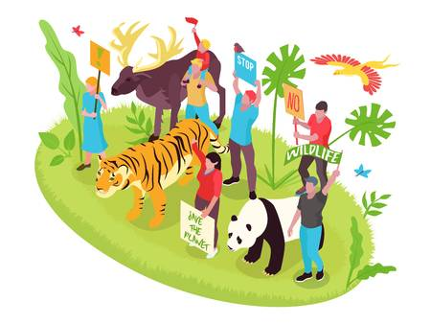
Levels of Biodiversity
1) Define Genetic Diversity.
2) Define Species Diversity.
3) Define Ecosystem Diversity.
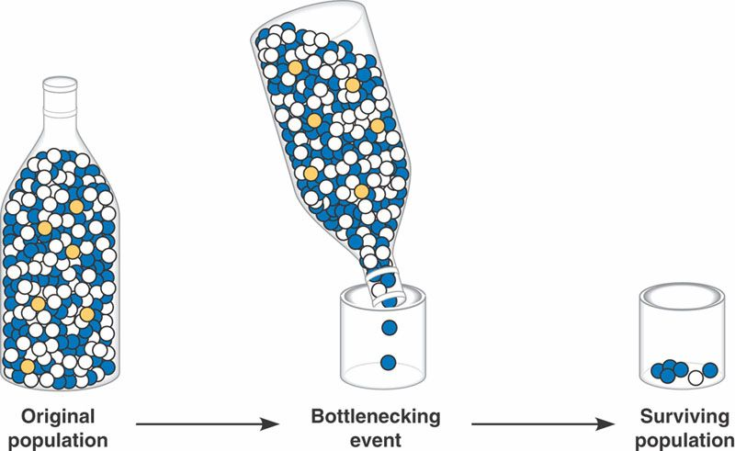
4) Describe how the picture to the left relates to genetic and species diversity.

Specialist vs Generalist Species
5) Compare a specialist to a generalist species. Give an example of each type of species.

6) Is a generalist or specialist more likely to survive in a changing environment? Explain.

7) Match the following:
  - generalist species Zebra mussel
  - specialist species Galapagos tortoise
  - invasive species American Alligator
  - keystone species Tiger salamander
  - indicator species Norway rat
  - endemic Species Giant Panda

Species Richness and Relative Abundance
8) Define Species Richness. How is it calculated?

9) Define Relative abundance. How is it calculated?

10) What do these two things reveal about an ecosystem? Why?

Ecosystem Services
11) Fill in the chart below on the different types of ecosystem services
Service Type | Define | Give a Real World Example
Provisioning

Regulating

Cultural

Supporting

12) Complete the following table:
Ecosystem Component | Ecosystem Services
honey bee
water cycle
forest
bat
bacteria
coral reef
wetland

Anthropogenic Effects on Ecosystem Services
13) Describe 5 ways that humans have disrupted ecosystem services on earth:
a)
b)
c)
d)
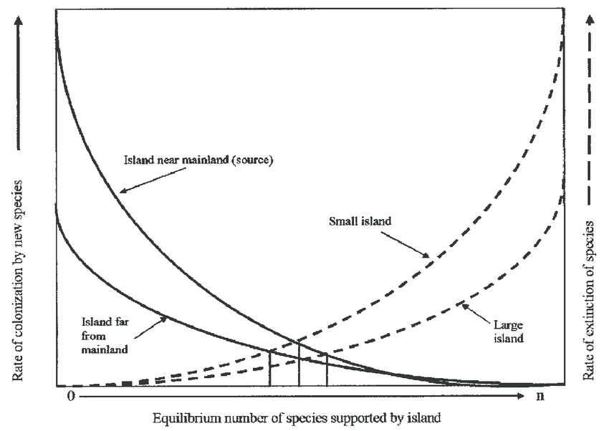
e)
Island Biogeography Theory
14) Two islands, different distances from the mainland have different rates of extinction, this is explained by the theory of island ________________________.

15) Describe the trends observed in the image to the right.

16) Why are island specialists susceptible to extinction?

Ecological Tolerance
17) What is the range of tolerance? How can one determine what it is?

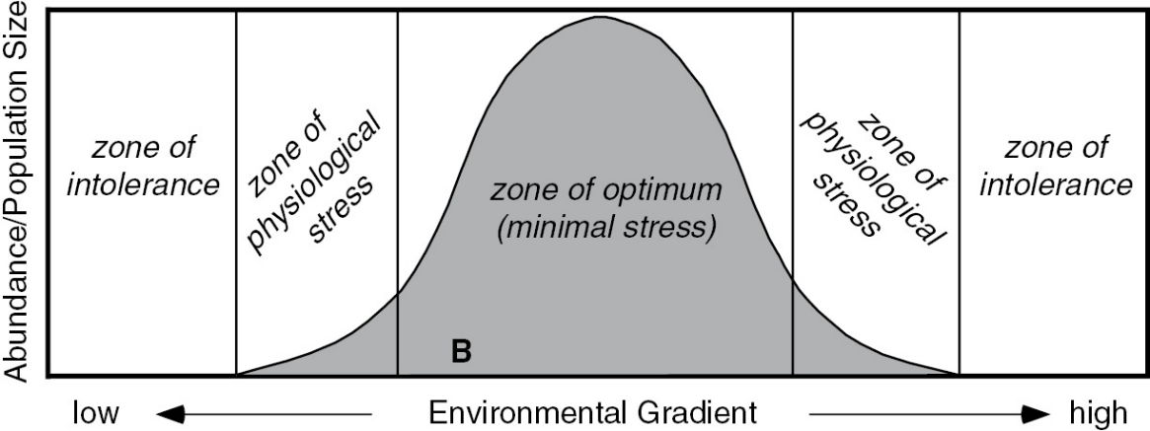
18) Define the terms in the picture below:
a) Zone of Intolerance
b) Zone pf physiological stress
c) Zone of optimum

Natural Disruptions
19) What are some examples of natural disruptions to the environment?
20) Compare resistance to resilience in terms of ecosystems.
Plant Adaptations to Fire
21) What biomes need fire for plant germination?
22) How have plants adapted to fire? Give at least two examples.
Ecological Succession: Primary vs Secondary
23) Compare and contrast primary to secondary succession. Give examples of each.
24) Define pioneer community.
25) Define climax community.
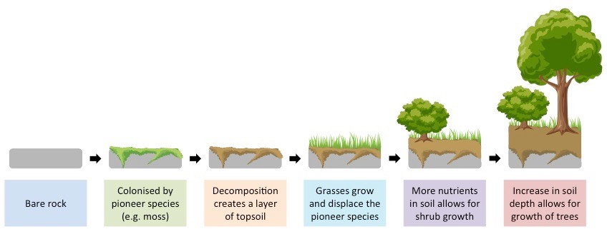
26) What type of succession is illustrated above? How can you tell?

Species: Indicator and Keystone Species
27) Define a keystone species. Give at least two examples.
28) Define an indicator species. Give at least two examples.
Sample FRQ’s
29) Biological diversity, or biodiversity, has become a topic of great concern among conservationists. Biodiversity is often used by scientists and policy makers to help determine the health of ecosystems.
(a) Describe TWO characteristics shared by ecosystems that have high biodiversity.
(b) Identify TWO specific human activities that result in a loss of biodiversity, and explain how each activity lowers biodiversity.
(c) For each human activity you discussed in (b), propose a practical strategy (other than simply banning the activity) to reduce the loss of biodiversity.
(d) Describe ONE naturally occurring factor that could lead to a loss of biodiversity.
(e) Describe TWO ecological benefits that greater biodiversity provides.
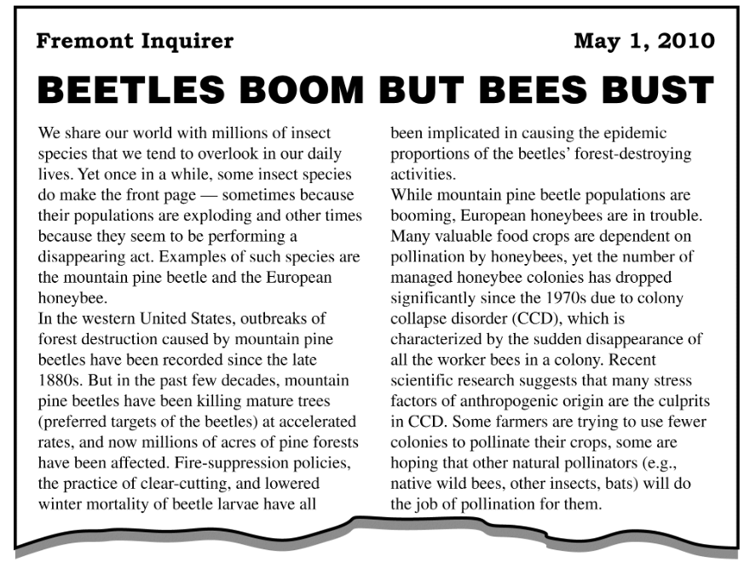
30) Read the following article from the Fremont Inquirer and answer the questions that follow.

(a) As mentioned in the article, there are several possible explanations for the increase in mountain pine beetles.
(i) Provide one reason why fire-suppression policies lead to increased beetle activity.
(ii) Reduced winter mortality of beetle larvae is likely a consequence of global climate change. Describe TWO ways that the activities of the beetles might enhance climate change.

(b) The widespread death of trees leads to a series of changes in a forest ecosystem. Identify TWO physical changes that occur in the forest ecosystem as the result of the death of mature trees. For each physical change you identify, describe an impact of that change on the forest ecosystem.
(c) As the article states, the number of managed honeybee colonies has dropped significantly over the past few decades. Describe TWO specific economic consequences of the collapse of the managed honeybee colonies.
(d) Pollination by native insects is considered an ecosystem service. Identify a different ecosystem service and explain how that service benefits human society.
Modified by A. Willis from David Hong’s AP Environmental Science Review Packets (Diamond Bar HS). FRQ’s are College Board Released.
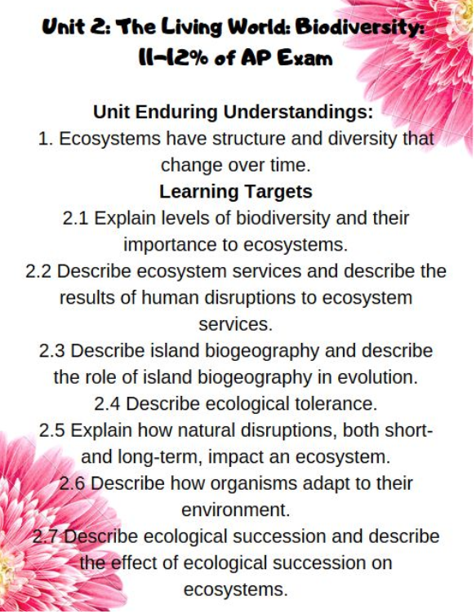
Unit 2 The Living World Biodiversity Review Videos
Mr. Andersen, Bozeman Biology
009 - Ecosystem Diversity
010 - Natural Ecosystem Change
055 - Biodiversity
Ted Ed
Why is Biodiversity So Important? https://www.youtube.com/watch?v=GK_vRtHJZu4
Dead Stuff: https://www.youtube.com/watch?v=KI7u_pcfAQE
How Long Will Human Impacts Last? https://www.youtube.com/watch?v=Zsc8G0NnMTs
A Threat of Invasive Species: https://www.youtube.com/watch?v=spTWwqVP_2s

Mrs. Campbell’s APES
Range of Tolerance: https://www.youtube.com/watch?v=Eo9bJVx6iyI
Island Biogeography: https://www.youtube.com/watch?v=8e_C4QWy_pI

Fuse School
Generalist vs Specialist Species: https://www.youtube.com/watch?v=bswS-Ooe4iQ

California Academy of Science
Ecosystem Services: https://www.youtube.com/watch?v=BCH1Gre3Mg0

HHMI BioInteractive
Keystone Species: Some Animals are More Equal Than Others: Trophic Cascades https://www.youtube.com/watch?v=hRGg5it5FMI

Crash Course
Ecological Succession: Change is Good Crash Course Ecology #6: https://www.youtube.com/watch?v=jZKIHe2LDP8&list=PL8dPuuaLjXtNdTKZkV_GiIYXpV9w4WxbX&index=6
Ecosystem Ecology: Links in the Chain Crash Course Ecology #7: https://www.youtube.com/watch?v=v6ubvEJ3KGM&list=PL8dPuuaLjXtNdTKZkV_GiIYXpV9w4WxbX&index=7

Khan Academy
Ecological Succession: https://www.youtube.com/watch?v=d7xbyNSxxrI&list=PLbjyLFA2XFZyvLJTz-oWEUURQtwnf32eP&index=11

Barron’s Review Chapters, 7th Edition
Chapter 4: Ecosystems (Pg 91)
Chapter 5: Natural Biogeochemical Cycles (Pg 145)
Chapter 7: Land and Water Use, Forest Fires (Pg 213-213)

Unit 2 The Living World: Biodiversity Vocabulary
species richness : The number of different species in a community.
Relative abundance: The number of how many individuals are present for each species.
Ecology: study of living organisms in their nonliving world
Biotic factor: living item (ex: bacteria)
Abiotic factor: not living item (ex: rock)
Ecosystem service: the many and varied benefits to humans gifted by the natural environment and from healthy ecosystems.
Ecological Hierarchy: species population community ecosystem biome biosphere
Population: a group of individuals of the same species
Community: a group of populations interacting together
Ecosystem: a group of communities interacting together
Biosphere: another name for earth
Natural Selection: survival of the fittest
Salinity: level of salt in the water
Brackish: medium levels of salinity. Often occurs in wetlands where salt and fresh water mix.
Gaia hypothesis: organisms interact with their inorganic surroundings on Earth to form a synergistic self-regulating, complex system that helps to maintain and perpetuate the conditions for life on the planet
Range of Tolerance: range of environmental conditions that are tolerable for survival in a species
Ecological footprint: a measure of human impact on Earth's ecosystems. It's typically measured in area of wilderness or amount of natural capital consumed each year.
Primary Succession: community change that occurs with new land formation: lichen moss small shrubs small trees large trees climax community
Secondary Succession: community change that occurs with land already formed.
Bottleneck Effect: cut down of genetic diversity due to loss of individuals in a population.
Non-native species: a species that is not known historically in an area. Ex: cane toads in Australia
Species diversity: a count of how many species are in an area.
Ecotone: a transitional zone between two communities. Ex: intertidal zone.
Niche: an organism’s job in a community.
Hybrid: the offspring of two different species.
Lichen: a symbiotic relationship of a fungus and an algae
Germination: sprouting of a seed
Competitive Exclusion Principle: species with the same niche in the same area cannot coexist
Keystone Species: often a dominant predator whose removal allows a prey population to explode and often decreases overall diversity. Ex: sea otter
Predation: the preying of one animal on others.
Mimicry: the close external resemblance of an animal or plant (or part of one) to another animal, plant, or inanimate object
Aerobic: using oxygen
Anaerobic: using no oxygen

