Unit 3 Populations APES Exam Review
Population Math
1) Write an equation for the rule of 70: . What is it used for?
2) Perform the following calculations: (Show all of your work in a logical progression to the final answer.)
  - A city has a population of 50,000 in 2012. If the population of the city grows at an annual rate of 2%, the year in which the population will reach 100,000 is _____________ and the year it will reach 200,000 is _____________.
Show work:

  - A country’s population was 12 million in 1992 and in 2012 it is 24 million. If the population grew at a constant rate, that percent rate of growth was _____________.
Show work:

  - Perform the following calculation. Show all of your work. In a particular year a population has the following characteristics: the crude birth rate is 45, the crude death rate is 20, the immigration rate is 1%, and the emigration rate is 0.5%. The percent rate of growth for that year is __________.
Show work:

Population Changes and Population Momentum
3) What are the four factors used to determine population growth? What is the equation?
4) From the equation in #3, what factors add organisms to a population? Which ones remove organisms from a population?
5) What is population momentum?

R vs K Selected Species
6) List two characteristics of an r-selected species.
a) b)
7) List two characteristics of a K-selected species.
a) b)
8) A Whooping Crane is a _____________________ (r or k selected species) and it is endangered because of the following:
9) A California Condor is a _____________________ (r or k selected species) and it is endangered because of the following:
10) An Orangutan is a _____________________ (r or k selected species) and it is endangered because of the following:
11) A Dodo was a _____________________ (r or k selected species) and it is extinct because of the following:

Exponential and Logistic Growth, Carrying Capacity
Population
Time
12) Use the axes to the right for the following:
- Draw and label a line that represents linear growth.
- Draw and label a line that represents exponential growth.
- Draw and label a line that represents logistic growth. Label the carrying capacity.

Density Dependent vs Density Independent Factors
13) What is the difference between density dependent and density independent factors? Give examples of each.
Survivorship
Time
Survivorship Curves
14) Using the axes on the right, draw and label three survivorship curves exemplifying early-loss, late loss, and constant-loss species.

Country Case Studies, Developed vs Developing
15) List the four most populated countries in the world and their current population size.
(1) (3)
(2) (4)
16) Complete the following table by writing “high” or “low” in each box below.
Characteristic | More Economically Developed Counties (MEDCs) | Less Economically Developed Countries (LEDCs)
per capita GDP
degree of industrialization
infant mortality rate
per capita fossil fuel use
ecological footprint
greenhouse gas emissions
risk from heart disease
risk from infectious diseases

17) How did China and India slow their population growth down? What are the advantages and disadvantages of these policies?

Age Structure Diagrams
18) On the axes below, draw and completely label four age-structure diagrams that represent slow growth, rapid growth, negative growth, and zero population growth (include labels on the x- and y-axes)

Demographic Transition
19) Use the axes below to draw and label lines representing the birth rate, death rate and total population size during the idealized demographic transition of a country. Include, written directly onto the graph, an explanation for each change in the birth rate, death rate and total population size.
Rate / Population size
Time

Replacement Level, Infant Mortality, and Total Fertility Rates
20) Define the following:
  - total fertility rate:
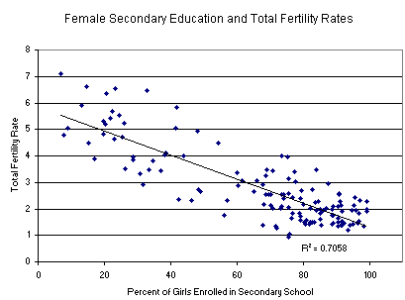
  - replacement level fertility
  - infant mortality rate
  - crude birth rate
  - crude death rate

21) Consider the graph on the right and explain what can be inferred from the data it presents.

US Demographics
22) What factors affect America’s population demographics?

23) What is the number one way to decrease population size?

Death Rate Declines
24) Why have death rates decreased in the last one hundred years?

Urbanization
25) Match the ten most populous urban areas in the world with its respective continent:
____ Sao Paulo ____ Tokyo a. Asia
____ Delhi Seoul b. North America
____ Osaka/Kobe Mexico City c. South America
____ Shanghai ____ New York City d. Africa
Mumbai e. Australia
f. Europe
26) What is urban sprawl?
27) What are three environmental negative effects of urban sprawl?
28) What is zoning?
29) Why do citizens leave rural areas to live in urban areas?

Environmental Impacts of Population Growth
30) Describe three environmental impacts caused by the increase of humans on this Earth.

Sample FRQ’s
31) Answer the following regarding world human population. (a) Create a graph of the data from table 1 below on the axes provided.
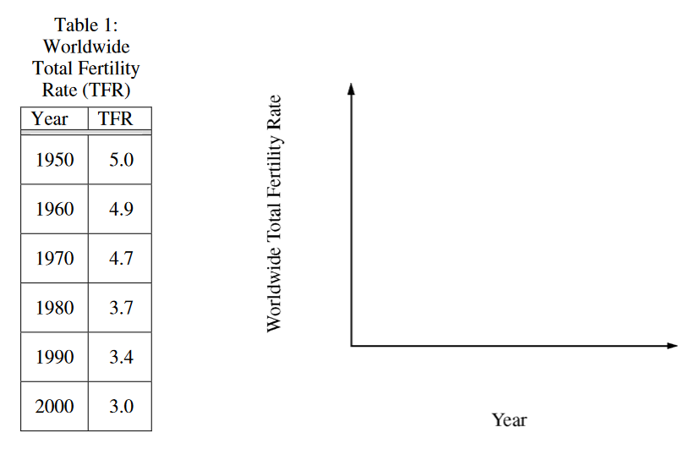
(b) Identify and discuss TWO of the causes for the trend in the worldwide TFR that you graphed in part (a).
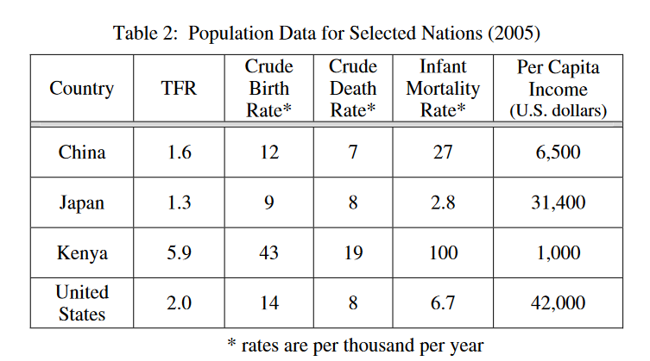

(c) Consider the data in table 2 above. Identify and discuss TWO economic or societal factors that account for the difference between the TFR of Kenya and that of the United States.
(d) Describe TWO human activities related to the rapidly growing world population that are having an impact on Earth’s biodiversity.

32) A certain fictional country called Industria is tracking its population data. In 1855, the first year vital statistics were reported for the country, the population was 1.6 million, with a crude birth rate of 43 per 1,000. At that time the population of Industria was growing quite slowly, because of the high death rate of 41 per 1,000. In 1875 the population began to grow very rapidly as the birth rate remained at its 1855 level, while the crude death rate dropped dramatically to 20 per 1,000. Population growth continued to increase in the small country into the late 1800’s, even though birth rates began to decline slowly. In 1895 the crude birth rate had dropped to 37, and the death rate to 12 per 1,000. In that year (1895) a complete census revealed that the population of Industria had grown to 2.5 million. By 1950 population growth gradually began to decline as the death rate remained at its 1895 level, while the birth rate continued to decline to 22 per 1,000. In 1977 vital statistics revealed that the death rate was 10 per 1,000, and that population growth had slowed even more to an annual rate of 0.4%. By 1990 Industria had reduced its birth rate to that of its now constant, low death rate, and the population transition was complete.
(a) On the axes below, plot the crude birth-rate data from 1855 to 1990. Now plot the crude death-rate data on the same axes. Clearly label the axes and the curves.

(b) What was the annual growth rate of Industria in 1950 ? What was the birth rate in Industria in 1977 ?
(c) Indicate TWO factors that might have accounted for the rapid decline in the death rate in Industria between 1855 and 1895. Indicate one specific reason why the birth rate might have been so high in 1855 and was so slow to decrease between 1855 and 1950.
(d) Determine what the population size of Industria would have been in 1951 if the population had continued to grow at the annual rate of growth recorded for Industria in 1895
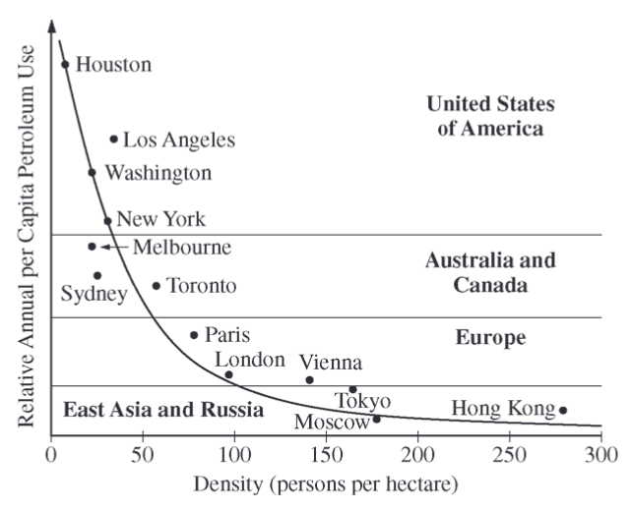
33) The term “urban sprawl” describes the expansion of cities into rural areas. This phenomenon has occurred around the world and has had economic, health, and environmental consequences.
(a) Describe TWO causes of urban sprawl.
(b) Discuss TWO human health effects associated with urban sprawl.
(c) The graph to the right shows the relationship between population density and petroleum use in selected cities. Describe the relationship between population density and petroleum use shown in the graph.

Modified by A. Willis from David Hong’s AP Environmental Science Review Packets (Diamond Bar HS). FRQ’s are College Board Released.

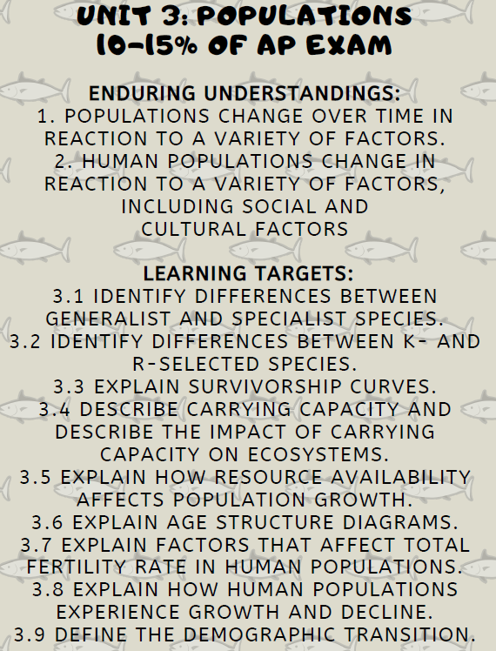
Unit 3 Populations Review Videos
Mr. Andersen, Bozeman Biology
012 - Population Ecology
013 - Human Population Dynamics
014 - Human Population Size
015 - Human Population Impacts
R and K Selection: https://www.youtube.com/watch?v=Bu6ouKt9zhs
Logistic Growth: https://www.youtube.com/watch?v=rXlyYFXyfIM
Exponential Growth: https://www.youtube.com/watch?v=c6pcRR5Uy6w

Ted Ed
Population Pyramids: https://www.youtube.com/watch?v=RLmKfXwWQtE

Crash Course
Human Population Growth: https://www.youtube.com/watch?v=E8dkWQVFAoA
Population Ecology: https://www.youtube.com/watch?v=RBOsqmBQBQk

Khan Academy
Population Dynamics: https://www.youtube.com/watch?v=4CAQN-nc8Ac
Demographic Transition: https://www.youtube.com/watch?v=6P2bsPWCRvM

Barron’s Review Chapters, 7th Edition
Chapter 6: Populations (Page 165)

Unit 3 Populations Vocabulary
Demography: the branch of sociology that studies the characteristics of human populations
Census: a period count of the population
Population Density: number of individuals per unit area
Population Composition: structure of a population in terms of age, sex and other properties, education
Age-Sex Pyramid: graphic representation of a population showing the percentage of the total population by age and sex
Crude Birth Rate: the number of live births yearly per thousand people in a population
Crude Death Rate: The number of deaths per year per 1,000 people.
Infant Mortality: the death rate during the first year of life
Total Fertility Rate: The number of children born to an average woman in a population during her entire reproductive life
Demographic Transition: change in a population from high birth and death rates to low birth and death rates due to industrialization
Doubling Time: the time required for a population to double in size
Exponential Growth: growth pattern in which the individuals in a population reproduce at a constant rate
Linear Growth: Expansion that increases by the same amount during each time interval.
Natural Increase: Crude death rate subtracted from crude birth rate
Population Explosion: the rapid growth of the world's human population during the past century
Nomadism: movement among a definite set of places
Seasonal Movement: Movements that are taken based on a seasonal basis.
Migration: the movement of organisms from one population to another
Emigration: migration from a population
Immigration: Migration into a population
Refugee: an exile who flees for safety
Immigration Laws: laws and regulations of a state designed specifically to control immigration into the state
Negative Population Growth: the actual decline in population due to less than replacement births or extensive diseases
Population Momentum: Continued growth of a population due to a high number of individuals at child bearing age.
Doubling Time: The amount of time it takes for a population to double in size. Calculated by TD = 70/r (%)

