Unit 4 Earth Systems APES Exam Review
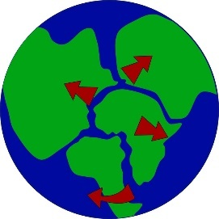
Plate Tectonics
1) What are the four layers of the Earth? Describe the composition of each layer.
2) Compare and contrast continental and oceanic crust.
3) Compare a divergent with a convergent plate boundary.
4) Why are plates moving? Draw a diagram with the explanation.
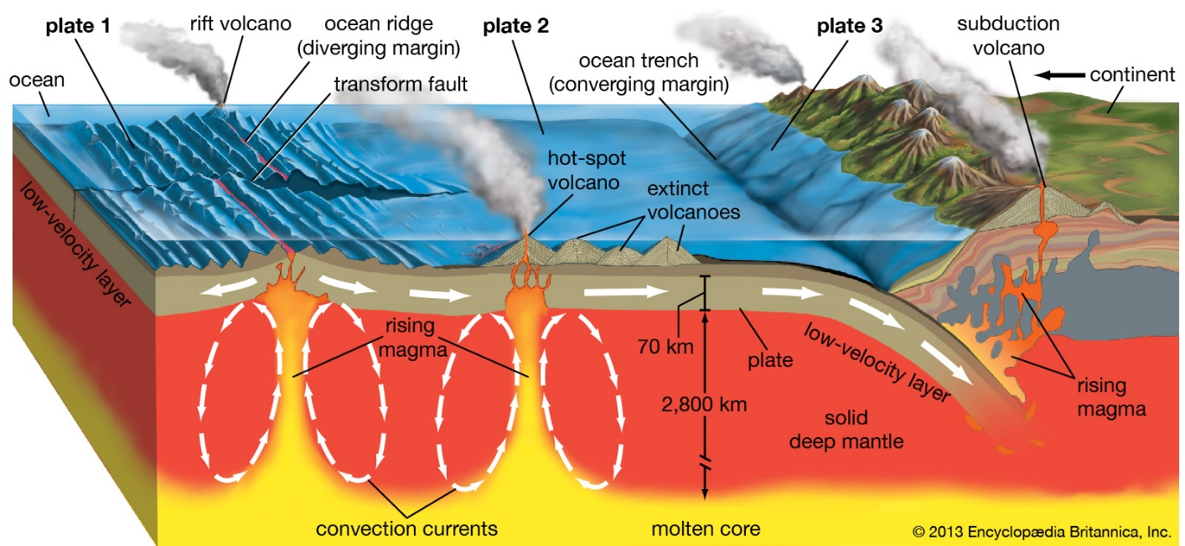
5) Why do oceanic plates dive underneath continental plates when they collide? What is this process called and what is created?

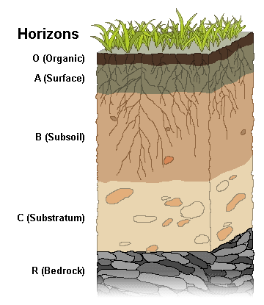
Geographic Features from Plate Tectonics
6) What is a mid-oceanic ridge? Where is it formed? Give an example of one.
7) How are mountains made?
8) What two plates are grinding together to form the San Andreas fault in California? What type of plate boundary exists here?
9) How are island arcs and trenches made?
Soil Formation and Soil Horizons
10) What is soil made of? How is it made?
11) Identify what can be found in each horizon:
a) O
b) A
c) B
d) C
e) R
Soil Conservation
12) Describe four techniques that keep soil in place:
a)
b)
c)
d)
Soil Composition
13) Arrange the following particles in order of smallest to largest: clay, sand, silt.
Altitude (km)
Temperature (°C)
14) Compare porosity to permeability.

Earth’s Atmosphere
15) Use the axes to the right for the following:
  - Draw a line representing the temperature as you increase in altitude through the atmosphere.
  - Label each layer of the Earth’s atmosphere and identify where the greenhouse effect occurs and the ozone layer is situated.

16) List causes of an urban heat island.
a)
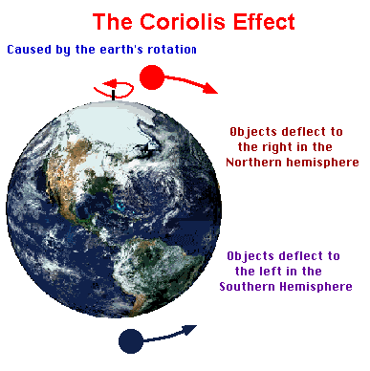
b)
c)

Global Wind Patterns and the Coriolis Effect
17) How is wind created?
18) How does wind control ocean currents?
19) What is the Coriolis effect? How does this affect wind and water movement on earth?
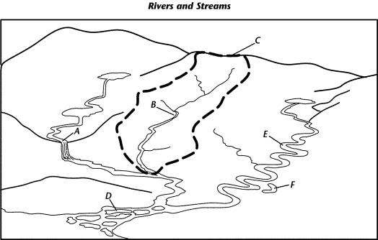
Watersheds
20) Explain what a watershed is and why it is significant.
21) Identify what A, B, C, and D are in the watershed diagram to the right.

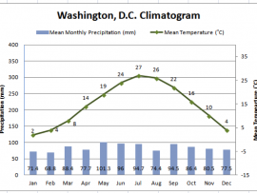
Solar Radiation and Seasons
22) Why do we have seasons?
23) How does solar radiation differ in the Northern Hemisphere winter and summer?
24) What are equinoxes?
Reading Climatograms
25) A climatogram of Washington, D.C. is presented to the right. What does a climatogram show?

26) Answer these questions using the graph:
a) In which month do we see the highest temperatures? How did you determine this?
b) In which month do we see the highest precipitations amounts? How did you determine this?
Earth Geography and Climate: Rain Shadow
27) The box to the right contains a crude depiction of a mountain, use it to sketch and label the essential atributes of a rain shadow. Include labels for the direction of the prevailing winds and nearest ocean.

ENSO aka El Nino and La Nina
28) The acronym ENSO refers to _____________ _____________ _____________ _____________, which occurs in the _____________ ocean.
29) Explain what an El Niño event is and why it is significant. What are the effects of an El Nino event?
30) Compare El Nino to La Nina.
Ecological Footprints
31) Define the term ecological footprint.
32) How does an ecological footprint of a developed country compare to a developing country? Why?

Sample FRQ’s
33) Suppose that you have just started a summer internship working for a cooperative extension service, where you will collect soil samples, conduct laboratory and field tests, and make recommendations on soil conservation and agricultural practices.
(a) Identify and describe one chemical soil test and one physical soil test that could be performed and explain how the results of these tests will allow the cooperative extension service to make specific recommendations for sustainable agriculture.
(b) Explain one advantage and one disadvantage to using inorganic commercial fertilizers.
(c) Describe TWO soil conservation practices that are designed to decrease soil erosion.
(d) Identify one biome that is characterized by soil that is rich in humus. Describe how humus originated in the soils of this biome and TWO ways that humus improves soil conditions for plant growth.

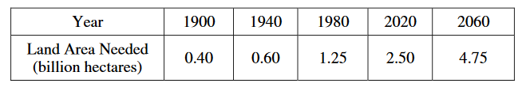
34) As the world’s population increases and availability of new arable land decreases, providing sufficient food for the world’s human population is becoming increasingly difficult. The table below shows the area of land needed to feed the world’s population from 1900 projected to the year 2060.

(a) On the graph below, plot the data from the table above and draw a smooth curve.
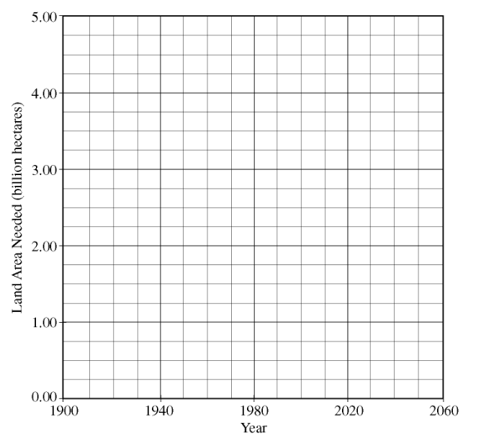
(b) Assume that the maximum arable land area on Earth is 4.00 billion hectares. Using the smooth curve that you created above, determine the year in which the human population is likely to run out of arable land for agriculture.
(c) Soil quality is a critical factor in agriculture. Identify TWO physical and/or chemical properties of soils and describe the role of each property in determining soil quality.
(d) Describe TWO viable strategies for reducing the amount of land needed for agriculture.

Modified by A. Willis from David Hong’s AP Environmental Science Review Packets (Diamond Bar HS), 2020. FRQ’s are College Board Released.
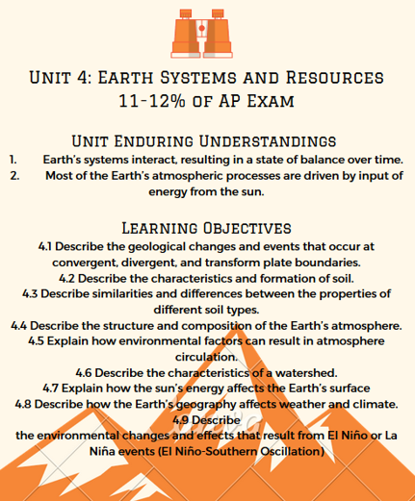
Unit 4 Earth Systems Review Videos
Mr. Andersen, Bozeman Biology
002 - Environmental Systems
003 - Geology
004 - The Atmosphere
006 - Soil & Soil Dynamics

Mrs. Campbell’s APES Page
Solar Radiation and Earth Season’s: https://www.youtube.com/watch?v=1WQYGUJFKtM
Earth’s Atmosphere: https://www.youtube.com/watch?v=jYGmu2cvjDA

Battle River Watershed
What is a watershed: https://www.youtube.com/watch?v=QOrVotzBNto

Earth Rocks
Seasons: https://www.youtube.com/watch?v=tX3Y5bzNDiU

Crash Course
Earth Science: https://www.youtube.com/watch?v=V2381lUhqc0
Coriolis Effect: https://www.youtube.com/watch?v=rdGtcZSFRLk&list=PLIRCOr8Z3UMVdcoz1mZfkij29HpBSB5k_

National Geographic
Atmosphere: https://www.youtube.com/watch?v=1YAOT92wuD8

Barron’s Review Chapters, 7th Edition
Chapter 1: The Earth (Page 11)
Chapter 2: The Atmosphere (Page 41)

Unit 4 Earth Systems Vocabulary
asthenosphere- the soft, flexible upper layer of the mantle, on which the tectonic plates move
continental drift- the theory that all of Earth’s continents were once joined together into a single large landmass, and then moved apart, forming the continents we see today
convection- transfer of heat by movement of a fluid
convection currents- movement within hot fluids, when the heat source is on the bottom, such as in a boiling pot of soup on the stove. Convection currents happen because the hotter material is less dense and rises; when it reaches the surface, it cools and becomes less dense, so it sinks. This rising and sinking creates a circular motion within the fluid.
convergent plate boundaries- where two tectonic plates move toward each other
divergent plate boundaries- where two tectonic plates move away from each other
Gondwana- the southern continent formed when Pangaea split into two pieces
Laurasia- the northern continent formed when Pangaea split into two pieces
lithosphere- the rigid, brittle layer made up of the crust and the uppermost part of the mantle. It is broken up into pieces called tectonic plates.
mantle convection- convection currents in the mantle that occur because hot rock in the lower part of the mantle is less dense and rises, and cooler rock in the upper part of the mantle cools, becomes more dense, and sinks. Mantle convection is thought to be the mechanism driving the movement of tectonic plates.
mid-ocean ridge- a system of connected underwater mountain ranges that run throughout the world’s oceans. There is a rift valley in the center of the mid-ocean ridge, where magma rises up from the mantle, and pushes out to either side, producing seafloor spreading.
Pangaea- (“all land”) the single huge supercontinent that existed 245 million years ago, when all of Earth’s continents were joined together.
seafloor spreading- the process by which new oceanic crust forms when magma rises up and solidifies at the mid-ocean ridges. The newer crust pushes the older crust out to each side, which is why the age of the sea floor increases with distance away from the mid-ocean ridges.
subduction- the process by which one tectonic plate sinks below another, returning to the mantle, where the rock is re-melted. Subduction takes place at convergent plate boundaries. Oceanic crust, which is denser, will always subduct under the less dense continental crust.
tectonic plates- large pieces of the lithosphere that slowly move on top of the asthenosphere. There are seven primary plates and many smaller ones. The seven primary plates are the African Plate, Antarctic Plate, Eurasian Plate, Indo-Australian Plate, North American Plate, Pacific Plate, and South American Plate.
tectonic plate boundary- a place where two tectonic plates meet
transform plate boundary- where two tectonic plates slip past each other, moving in opposite directions
atmosphere: The layer of air that surrounds the Earth (like a blanket). The atmosphere is made up of a mixture of gaseous elements and compounds and a small amount of tiny solids and liquids. The atmosphere is held close to Earth due to gravity.
Thermosphere: The atmospheric layer between the mesosphere and the exosphere where the molecules contain the most heat energy; the Northern and Southern lights, known as the auroras are found here. The ionosphere; the temperature increases as altitude increases.
Mesosphere: The middle layer of Earth’s atmosphere where most meteoroids burn up. The temperature decreases as altitude increases.
jet stream: “Rivers” of high-speed air in the atmosphere, found in the top section of troposphere/early stratosphere. It affects air masses and affects aircraft by speeding or slowing their path.
ozone layer: A layer of a special kind of oxygen (ozone = O₃) found in the stratosphere that protects life on Earth from the sun’s harmful ultraviolet rays
stratosphere: The second layer from the Earth’s surface. It contains the ozone layer. The temperature increases as altitude increases due to the ozone layer’s absorption of ultraviolet rays from the sun.
troposphere: The lowest layer of the atmospheric, containing about 75% of all the air in the atmosphere. It contains the air we breathe and is where weather, clouds, and air pollution are found. The temperature decreases as altitude decreases
air pressure: The amount of force pushing on a surface or area.-Think about how your ears feel under water.....image that higher up in the atmosphere....what might they feel like.
low pressure: When air warms, its molecules scatter, the air becomes less dense and it rises. This causes low pressure. Air is usually cloudy and winds are particularly strong
high pressure: When air cools, its molecules move closer together, the air becomes more dense and it sinks. This causes high pressure. Weather is fair and winds typically light.
Radiation: The transfer of energy (including heat) through electromagnetic (light) waves. Examples include: radio, microwave, infrared, ultraviolet, visible light, x-rays, gamma rays
ultraviolet rays (UV radiation): A form of energy given off by light with wavelengths that are shorter than visible light. Ultraviolet rays are harmful to living things
wind: Horizontal movement of air from an area of high pressure to an area of lower pressure

