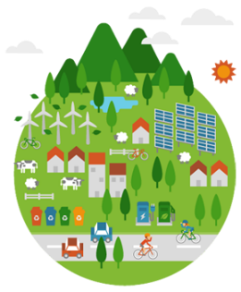
Unit 5 Land and Water Use APES Exam Review
Tragedy of the Commons
1) Describe the circumstances that will result in a Tragedy of the Commons.
2) Describe an example of a Tragedy of the Commons.
3) How are commons protected?
Clearcutting
4) What is clearcutting?
5) What are two environmental problems associated with clearcutting?
Green Revolution
6) What was the Green Revolution and why is it important?
7) List four innovations that led to the Green revolution.
a)
b)
c)
d)
Agricultural Practices and Impacts
8) Identify three examples organic compounds and three examples of inorganic compounds.
(1) (1)
Organic: (2) Inorganic: (2)
(3) ____________________ (3) __________
9) Humans began agriculture approximately ______________ years ago.

10) To live a healthy, active life most adults need to consume approximately ___________ calories of food each day.
11) Arrange the following foods in order of highest to lowest in terms of global production: corn (maize), rice, wheat
1) 2) 3)
12) Match the following:
  - anemia iron deficiency
  - goiter vitamin A deficiency
  - scurvy vitamin D deficiency
  - rickets iodine deficiency
  - blindness vitamin C deficiency

13) What is tilling? What are some environmental impacts of tilling?
14) Why do people do slash and burn? How does this impact the environment?
15) Compare inorganic to organic fertilizers. Which kind are more likely to runoff?

Irrigation Methods
16) For each irrigation method listed below, diagram how the method works.
Drip Irrigation | Flood Irrigation | Furrow Irrigation | Spray Irrigation
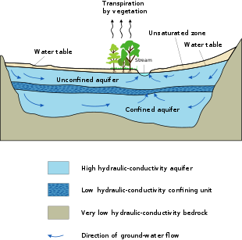
17) Which irrigation system is most efficient? Why? Least efficient? Why?

Salinization
18) What is salinization and how does it occur?
19) How do farmers deal with salinization?
Aquifers and Ogallala
20) What is an aquifer?
21) Where is the Ogallala aquifer located? What is this aquifer primarily used for?
22) How do impervious surfaces impact aquifers?
Pest Control Methods and IPM
23) Use the axes below to draw and label an illustration of the pesticide treadmill.
Pest Population
size
Time

24) Rachel Carson wrote the book ________ Spring to raise people’s awareness of the harmful effects of the pesticide ________.
25) DDT was a commonly used pesticide in in the 1950’s. Why is DDT considered a broad-spectrum pesticide? Why was it banned?
26) In the table below, list at least two advantages and disadvantages to chemical pesticides.
Advantages of Chemical Pesticide Usage | Disadvantages of Chemical Pesticide Usage

27) How does Integrated Pest Management differ from solely using chemical pesticides? Give some example of IPM methods.

GMO’s
28) The acronym GMO refers to _____________ _____________ _____________, which are:
29) In the table below, list at least two advantages and disadvantages of GMO’s.
Advantages of GMO Use | Disadvantages of GMO Use
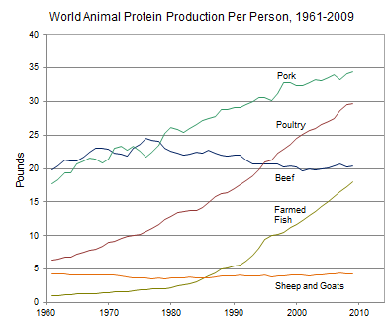
Meat Production Methods
30) Use the information in the diagram on the left, to answer the following:
- The percent change in the per capita global production of protein from poultry between 1980 and 2000 was approximately ________.
- The percent change in the per capita global production of protein from farmed fish between 1980 and 2000 was approximately ________.
- The percent change in the per capita global production of protein from beef between 1961 and 2009 was approximately ________.

31) Why is meat production inefficient?
32) Who eats more meat, developed or developing countries? Why?
33) Compare overgrazing to free grazing meat production methods. How can overgrazing lead to desertification?
Mining
34) Complete the following chart.
Mining Technique | Description | Environmental Consequences
Open-Pit mining
Subsurface mining
Strip mining
Mountaintop removal
Drilling
35) Strengthen this weak statement: “Mining causes pollution that may disrupt the environment.”
36) Match each of the following elements with its ore:
  - aluminum galena
  - iron quartz
  - uranium bauxite
  - lead hematite
  - silicon pitchblende
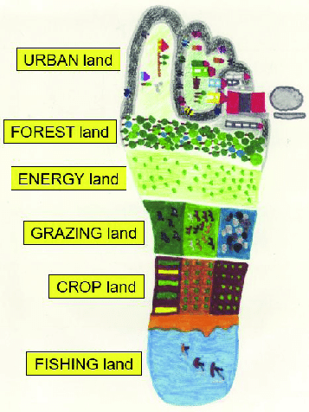
Ecological Footprints (Repeat)
37) Define the term ecological footprint.
38) How does an ecological footprint of a developed country compare to a developing country? Why?
Sustainable Agriculture
39) How do farmers keep their soil in place? Describe at least two techniques.
Sustainable Forestry
40) Math: A rectangular area of forest that measures 10 thousand meters by 300 thousand meters has an area of ___________ square kilometers and ___________ hectares.
Show work:

41) A company is importing rare tropical hardwood to manufacture furniture, list three laws, regulations, treaties, or acts that the company may have violated.
1)
2)
3)
42) For each of the methods below, describe how the process leads to sustainable forests:
a) Reforestation
b) Reusing Wood
c) Ecologically Sustainable Wood
d) Prescribed Burns
Fisheries
43) ________________________ is a technique typically used to harvest scallops, crabs, and shrimp from the sea floor.
44) A fishing practice that is commonly used to catch large solitary species of fish and was featured in The Perfect Storm is ________________________.
45) Compare a purse seine to a drift net.
46) What is bycatch? What are ghost nets?
Aquaculture
47) Aquaculture has increased in the past twenty years. What are some items that are commonly farmed in aquaculture?
48) In the table below, identify advantages and the disadvantages to fish farming.
Advantages of Aquaculture | Disadvantages of Aquaculture

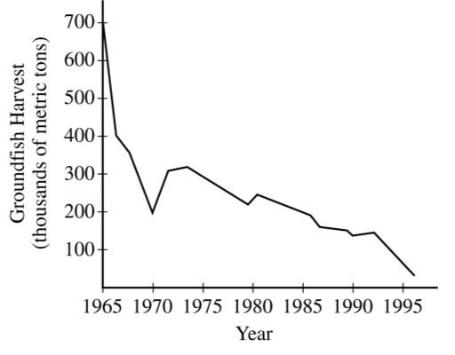
Sample FRQ’s
49) The graph to the right shows the decline in the catch of groundfish (such as cod, haddock, and flounder) from Georges Bank from 1965 to 1995. This decline in the fish harvest resulted in the closure of large portions of the fishery.
(a) Identify the five-year period during which the greatest rate of decline in the fish harvest took place. For that five-year period, calculate the rate of decline in the fish harvest, in metric tons per year. Show clearly how you determined your answer.
(b) Choose any TWO commercial fishing practices from the list below. For each of your choices, describe the practice and explain the role it plays in the depletion of marine organisms.• Bottom trawling • Long-line fishing • Using drift nets/gill nets/purse seines • Using sonar
(c) Identify one international regulation or United States federal law that applies to the harvesting of marine food resources and explain how that regulation or law helps to manage marine species.
(d) The oceans of the world are often referred to as a commons. Give an example of one other such commons, explain how human activities affect that commons, and suggest one practical method for managing that commons

50) The active ingredients in many pesticides are chemical compounds that kill organisms such as insects, molds, and weeds. Proponents claim that the use of pesticides improves crop yields and thus protects land and soil by reducing the conversion of forests and wetlands to cropland. Opponents of pesticide use claim that pesticides degrade water and soil quality and that other modern agricultural techniques and practices are responsible for the improved crop yields in recent years.
(a) Design a laboratory experiment to determine whether or not a new pesticide (product X) is toxic to minnows, a type of small fish. For the experiment you design, be sure to do all of the following.
(i) State the hypothesis.
(ii) Describe the method you would use to test your hypothesis.
(iii) Identify the control.
(iv) Identify the dependent variable.
(b) Describe experimental results that would lead you to reject your hypothesis in part (a)
(c) One strategy for dealing with agricultural pests is integrated pest management (IPM).
(i) Describe IPM. As part of your description, include TWO specific pest-control approaches that are part of IPM.
(ii) Identify one environmental benefit of using IPM.
(d) Describe TWO agricultural practices, other than those involving pest control, that increase crop yields.

Modified by A. Willis from David Hong’s AP Environmental Science Review Packets (Diamond Bar HS), 2020. FRQ’s are College Board Released.
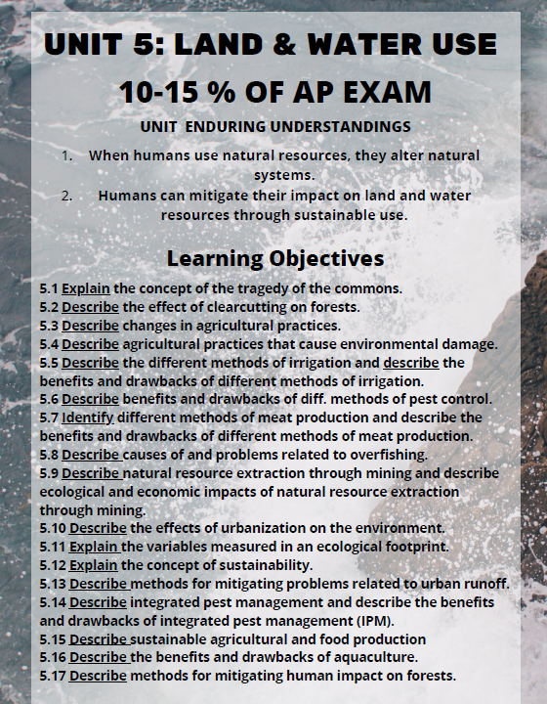
Unit 5 Land and Water Use Review Videos
Mr. Andersen, Bozeman Biology
016 - Agriculture
017 - Forestry & Rangelands
018 - Land Use
019 - Mining
020 - Fishing
021 - Environmental Economics

Ted Ed
Tragedy of the Commons: https://www.youtube.com/watch?v=CxC161GvMPc
Will the ocean ever run out of fish? https://www.youtube.com/watch?v=WNdR808jMSA
Underwater farms vs climate changes: https://www.youtube.com/watch?v=JYZpxRy5Mfg
The History of the World According to Corn: https://www.youtube.com/results?search_query=farming+ted+ed
Do we really need pesticides? https://www.youtube.com/watch?v=GLllZ-qiXJA

TEDx
Cows, Carbon, and Climate: https://www.youtube.com/watch?v=4Z75A_JMBx4

Crash Course/Sci Show
The Agricultural Revolution: https://www.youtube.com/watch?v=Yocja_N5s1I
How Safe are Pesticides? https://www.youtube.com/watch?v=eF_fbTbHdyg
Why are GMO’s Bad? https://www.youtube.com/watch?v=sH4bi60alZU
What does Organic Farming Mean? https://www.youtube.com/watch?v=UnuP4vrLvc4

Barron’s Review Chapters, 7th Edition
Chapter 3: Global Water Resources and Use (Page 67)
Chapter 7: Land and Water Use (Page 197)

Unit 5 Land and Water Use Vocabulary
Agricultural pollution- pollution from rural areas where few people live
Algae- a general term for small, chlorophyll-containing plants such as seaweed or pond scum
Ammonia- a colorless, pungent gas composed of nitrogen and hydrogen from animal waste
Aquaculture- the cultivation of aquatic organisms (as fish or shellfish) especially for food; fish farming.
Aquatic – living or growing in water
Aquifer – an underground water system made of porous rock and sand
Bottom trawling- fishing method that involves towing trawl nets along the sea floor.
By-catch-unwanted marine creatures that are caught in the nets while fishing for another species.
Condensation – when water vapor (gaseous water) forms droplets of water in the atmosphere, making clouds. The change in water from gas to liquid form.
Confining layer- a place in the aquifer where impermeable rock covers permeable rock
Evaporation – the change in water from liquid to gas
Eutrophication- When large amounts of nutrients enter the water and cause an increase in the amount of oxygen
Exotic Plant – A plant that is transported from its place of origin and introduced into a new environment
Groundwater – water that percolates through the surface and is retained in underlying rock and soil.
Groundwater contamination- when any harmful substance enters the water underground and makes it unsuitable for use Groundwater model- a representation of the underground water system
Groundwater system- holds the rock layers that make up an aquifer and the water that is stored and transported through the openings in the rocks
Herbicides- chemicals used to kill weeds
Hydrologic Cycle - the passage of water between reservoirs (oceans and atmosphere) by groundwater percolation, evaporation, condensation, and precipitation.
Impermeable- something that does not allow liquid to run through it
Marine protected area (MPA): officially, an MPA is any area of the marine environment that has been reserved by federal, state, tribal, territorial, or local laws or regulations to provide lasting protection for part or all of the natural and cultural resources therein. In practice, MPAs are defined areas where natural and/or cultural resources are given greater protection than the surrounding waters.
Native Plant – A plant that lives and thrives in its place of origin
Nitrate- a water-soluble molecule made up of nitrogen and oxygen, commonly found in agricultural fertilizers
Nitrogen- A colorless, odorless gas that is a non-metallic element which makes up almost four fifths of the air
Non- point source- when the point of the pollution is difficult to identify
Organic Pollution- pollution that occurs when living things decompose
Percolation – when precipitation is absorbed into the ground and moves down through the soil
Permeable- ability of something to allow liquids to run through it
Pesticides- chemical substances applied to plants to keep insects away
Phosphates- Phosphorous can come from natural sources such as phosphate- containing rocks and human sources such as fertilizers, pesticides, detergents, and industrial wastes.
Photosynthesis - the process by which plants convert energy from the sun into food
Phytoplankton - single celled algae
Point source- when the source of the pollutant is easily identified
Porous Rock – a rock with many spaces between grains.
Precipitation – water that is released from the atmosphere as rain, snow, hail, etc.
Sediment Pollution- pollution that occurs when loose soil is carried into bodies of water by rain
Spring – water returning to the surface after being absorbed by the ground
Stormwater runoff- rainwater that does not soak into the ground and carries pollution into bodies of water
Surface Runoff – precipitation that drains across the land into lakes, streams, or rivers
Surface Water - water that lays on the earth’s surface. Surface water includes water in rivers, lakes, streams, creeks, ponds, and wetlands
Transpiration – the process by which water is released from plans leaves
Watershed - an area of land over which water flows to reach a common body of water such as a lake or pond
Well- a hole that is drilled into the aquifer
Zooplankton – very small aquatic animals

