Unit 6 Energy Resources and Consumption APES Exam Review
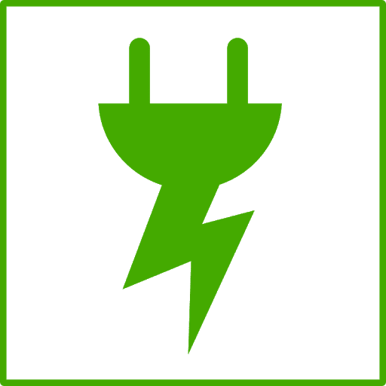
Nonrenewable vs Renewable Energy Sources
1) Compare a nonrenewable to a renewable energy source.
2) Identify three examples of renewable resources and three examples of nonrenewable resources.

Trends in Energy Consumption
3) How do developed and developing countries compare when it comes to energy consumption? Why?
4) What type of country (developed or developing) uses more fossil fuels? Why?
5) Does industrialization lead to high energy consumption rates? Why/why not?
Fuel: Wood Use in Developing Countries
6) Why is wood fuel commonly used in developing countries?
7) What are some environmental concerns with using wood as an energy source?
Coal
8) In the box to the right, list the ranks of coal in order from highest to lowest energy content. (indicate the addition of heat and pressurein the box.)
9) List three air pollutants that are emitted during the burning of coal.
a) b) c)
Natural Gas
10) List three sources of methane that are amplified by human activities.
11) How is methane naturally produced?
12) What is released when natural gas is burned (thus making it the “cleanest” fossil fuel)?
Crude Oil, Tar Sands, and Shale Oil
13) Place the following 8 events in chronological order: the oil spill of the Exxon Valdez; the meltdown of the reactor at Chernobyl; the discovery of contamination at Love Canal; The first Earth Day; the leak of methyl isocyanate in Bhopal; the drafting of the Kyoto Protocol; the ratification of the Montreal Protocol, passage of the US Endangered Species Act
a) e)
b) f)
c) g)
d) ____________________________________ h) ___________________________________________
14) Strengthen this weak statement: “Fossil fuel use releases carbon dioxide, which causes the greenhouse effect.”
15) List 4 products that are derived primarily from crude oil.
16) The acronym OPEC refers to the _____________ of _____________ _____________ _____________ and it is important because:
17) Explain what the Deepwater Horizon was, where it went, and why it is significant.
18) The acronym ANWR refers to the _____________ _____________ _____________ _____________ and it is important because:
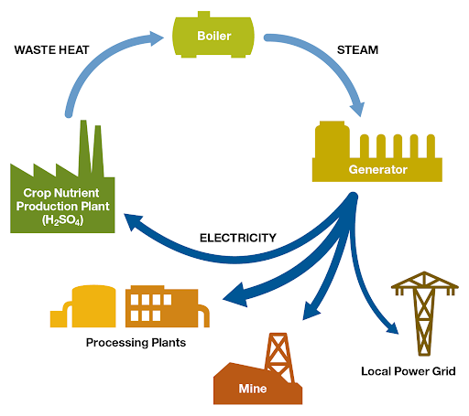
19) The acronym CAFE refers to the _____________ _____________ _____________ _____________ and it is important because:
20) Compare a tar sand to shale oil. What are some environmental concerns of each of these?
Cogeneration
21) What is cogeneration? Why does this process increase efficiency?

Energy Sources and their Locations: Most?
22) For each energy source, identify what country contains the largest amount of the energy source.
Energy Source | Location
Coal
Crude Oil
Natural Gas
Uranium 235
Geothermal

23) Rachel Carson wrote the book ________ Spring to raise people’s awareness of the harmful effects of the pesticide ________.
24) DDT was a commonly used pesticide in in the 1950’s. Why is DDT considered a broad-spectrum pesticide? Why was it banned?
Energy Conversion: From Energy Source to Electricity
25) Describe how fossil fuels are ignited and converted into electricity.
26) How to wind, geothermal, and hydroelectric operate?
Hydraulic Fracturing
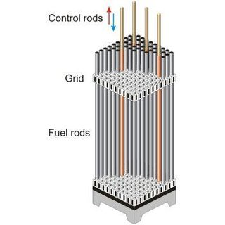
27) Fracking is short for ______________ ______________ and it is a concern because…
28) How does fracking pollute the groundwater?
Nuclear Power
29) Compare a fuel rod to a control rod. How do they work together?
30) State where Chernobyl is located and explain what happened there.
31) Explain what happened at Three Mile Island, and why it is significant.
32) Explain how thermal pollution is produced by power plants.
33) Explain what happened at Fukushima Daiichi and why it is significant
34) Perform the following calculation. Show all of your work. A radioactive cloud may contain Iodine-131, which has a half-life of 8 days. If the waste must decay to a concentration of less than 0.1% to be considered safe, it will take approximately ______ days to reach safe levels.
Show work:

Biomass and Biogas
35) What is biomass and how is it converted into an energy source?
36) What is biogas and how is it converted into an energy source?
Solar Energy
37) In the box to the right, sketch a house and the surroundings of a house that is designed to make the greatest use of passive solar energy in the northern hemisphere. Include, inside the box, the location of both the winter and summer sun, and labels to indicate the compass direction that the house faces.
38) Compare passive and active solar energy.
39) Perform the following calculation. Show all of your work. A 40 m² solar array is installed on a house where the average insolation is 6 kWh/m²/day if the average total electricity output of the array is 1.2 kWh/hr, the efficiency of the array is ____________.
Show work:
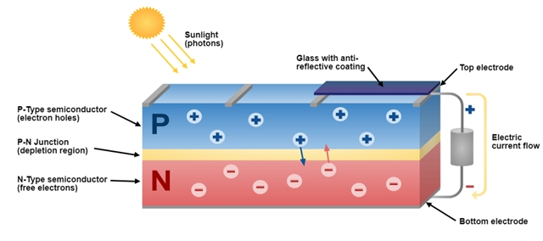
40) List three species that may be threatened by the construction of a solar power tower in the California Desert.

41) _______________ is the active element in most photovoltaic cells. How do PV cells work?
42) Compare off grid to on grid solar systems.
43) Arrange the following types of electromagnetic radiation in order from lowest to highest energy: Ultraviolet, Microwave, Infrared, Gamma, Radio, X-ray, Visible.

44) List the following types of visible light in order from shortest to longest wavelength: Green, Orange, Red, Yellow, Blue, Violet.

Hydroelectric Power
45) In the box to the right, draw a diagram that illustrates how electricity is produced by a dam
Geothermal Energy
46) How is geothermal energy generated?
Hydrogen Fuel Cell
47) Describe the basic components of a fuel cell? What are the limitations of fuel cells? What are the advantages of using fuel cells?
Wing Energy
48) How does a wind turbine work? What are the limitations of wind turbines? What are the advantages of using wind turbines?

Energy Conservation
49) List four things you could do to conserve energy.
Energy Math
50) If the cost of gas is $3.50 per gallon and the average gas mileage of a car is 25 mpg, the cost of driving the car per mile is _____________ $/mi, or _____________ ȼ/mi.
Show work:

51) Perform the following calculations: (Show all of your work in a logical progression to the final answer.)
  - A family has a total of 1500 Watts of light bulbs throughout their house, if they replace them all with LED light bulbs, which use 90% less energy, the family will now use _____________ Watts of electricity.
Show work:
  - A space heater operates at 1500 Watts, if it is used for 10 hours each day for one week and the cost of electricity is 20 cents per kilowatt-hour, it will cost _____________ to operate the heater for the week.
Show work:
  - A 60-Watt light bulb that is used for an average of 4 hours each day uses ___________ kilowatt-hours of electricity per year.
Show work:

Sample FRQ’s
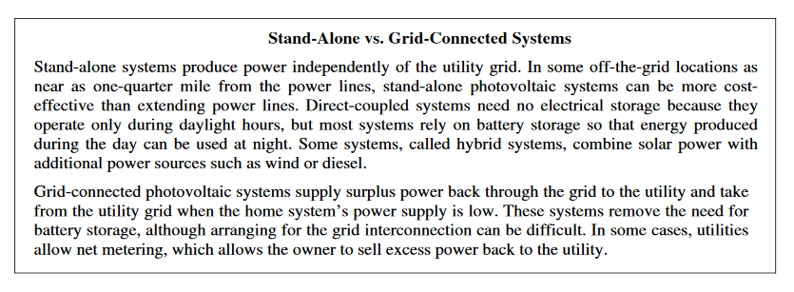
52) Upon receiving notice from their electric utility that customers with solar power systems are permitted to sell excess power back to the utility, an Arizona family is considering the purchase of a photovoltaic solar energy system for their 2,700-square-foot suburban home. The initial costs of the systems they are considering range from $7,000 to $30,000. While gathering information prior to making a decision, the homeowners find the following information at the Web site of the United States Department of Energy.
(a) Describe one environmental benefit and one environmental cost of photovoltaic systems.
(b) From the two types of solar systems described on the government Web site, select the system (either stand-alone or grid-connected) that you think best meets the needs of the homeowners. Write an argument to persuade them to purchase the system you selected. Include the pros and cons of each system in your argument.
(c) Describe TWO ways that government or industry could promote the use of photovoltaic power systems for homeowners in the future.
(d) Describe TWO ways that homeowners could use passive solar designs and/or systems and, for each way, explain how it would reduce the homeowners’ energy costs.

53) West Fremont is a community consisting of 3,000 homes. A small coal-burning power plant currently supplies electricity for the town. The capacity of the power plant is 12 megawatts (MW) and the average household consumes 8,000 kilowatt hours (kWh) of electrical energy each year. The price paid to the electric utility by West Fremont residents for this energy is $0.10 per kWh. The town leaders are considering a plan, the West Fremont Wind Project (WFWP), to generate their own electricity using 10 wind turbines that would be located on the wooded ridges surrounding the town. Each wind turbine would have a capacity of 1.2 MW and each would cost the town $3 million to purchase, finance, and operate for 25 years.
(a) Assuming that the existing power plant can operate at full capacity for 8,000 hrs/yr, how many kWh of electricity can be produced by the plant in a year?
(b) At the current rate of electrical energy use per household, how many kWh of electrical energy does the community consume in one year?
(c) Compare your answers in (a) and (b) and explain why you would or would not expect the numbers to be the same.
(d) Assuming that the electrical energy needs of the community do not change during the 25-year lifetime of the wind turbines, what would be the cost to the community of the electricity supplied by the WFWP over 25 years? Express your answer in dollars/kWh.
(e) Identify and explain TWO environmental benefits to West Fremont of switching from coal to wind power and TWO environmental costs to West Fremont of switching from coal to wind power.

Modified by A. Willis from David Hong’s AP Environmental Science Review Packets (Diamond Bar HS), 2020. FRQ’s are College Board Released.
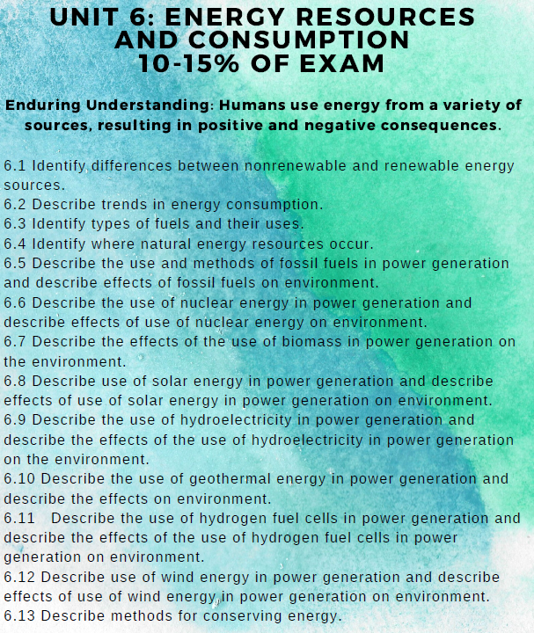
Unit 6 Energy Resources and Consumption Review Videos
Mr. Andersen, Bozeman Biology
022 - Energy Concepts
023 - Energy Consumption
024 - Fossil Fuel Resources
025 - Nuclear Energy
026 - Hydroelectric Power
027 - Energy Reduction
028 - Renewable Energy

Ted Ed
A Guide to the Energy on Earth: https://www.youtube.com/watch?v=fHztd6k5ZXY
Can 100% Renewable Energy Really Power the Earth? https://www.youtube.com/watch?v=RnvCbquYeIM
How do Solar Panels Work? https://www.youtube.com/watch?v=xKxrkht7CpY

National Geographic
Renewable Energy 101: https://www.youtube.com/watch?v=1kUE0BZtTRc
What are Fossil Fuels: https://www.youtube.com/watch?v=YTnE0OQPTEo

Fuse School
How do Fuel Cells Work? https://www.youtube.com/watch?v=5_lDGna9MBM

Barron’s Review Chapters, 7th Edition
Chapter 8: Energy (Page 249)

Unit 6 Energy Resources and Consumption Vocabulary
AFV—Alternative Fuel Vehicle. Natural Gas cars, fuel cell cars, electric cars
Biofuels—Alcohols, ethers, esters, and other chemicals made from raw biological material such as herbaceous and woody plants, agricultural and forestry residues, and a large portion of municipal solid and industrial waste.
Biomass—Organic waste from agricultural, livestock, and lumber industry products, dead trees, foliage, etc., and is considered a renewable energy source. Biomass can be used as fuel and is most often burned to create steam that powers steam turbine generators. It is also used to make transportation fuels like ethanol and biodiesel, and chemicals like pyrolysis oil that can be burned like oil to produce energy.
BTU—British thermal unit; the amount of heat required to raise the temperature of one pound of water one degree Fahrenheit under stated conditions of pressure and temperature (equal to 252 calories, 778 foot-pounds, 1,005 joules and 0.293 watthours). It is the U.S. customary unit of measuring the quality of heat, such as the heat content of fuel.
CO—Carbon Monoxide
CO₂ —Carbon Dioxide
Cogeneration—(also Combined Heat and Power) Production of electricity from steam, heat, or other forms of energy produced as a by-product of another process.
Demand—The rate at which electric energy is delivered to or by a system or part of a system, generally expressed in kilowatts (kW), megawatts (MW), or gigawatts (GW), at a given instant or averaged over any designated interval of time. Demand should not be confused with Load or Energy.
DOE—U.S. Department of Energy.
Electric Energy—The generation or use of electric power by a device over a period of time, expressed in kilowatt-hours (kWh), megawatt-hours (MWh), or gigawatt-hours (GWh).
Energy Conservation—Using less energy, either by greater energy efficiency or by decreasing the types of applications requiring electricity or natural gas to operate.
Energy Efficiency—Using less energy (electricity and/or natural gas) to perform the same function at the same level of quality.
EPA—U.S. Environmental Protection Agency.
Gigawatt-hour (GWh)—The unit of energy equal to that expended in one hour at a rate of one billion watts. One GWh equals 1,000 megawatt-hours.
Greenhouse gases—Greenhouse gases are water vapor, carbon dioxide, tropospheric ozone, nitrous oxide, methane, and chlorofluorocarbons (CFCs).
Grid—A system of interconnected power lines and generators that is managed so that power from generators is dispatched as needed to meet the requirements of the customers connected to the grid at various points.
Kilowatt (kW)—This is a measure of demand for power. The rate at which electricity is used during a defined period (usually metered over 15-minute intervals). Utility customers generally are billed on a monthly basis; therefore, the kW demand for a given month would be the 15- minute period in which the most power is consumed.
Kilowatt-hour (kWh)—This is a measure of consumption. It is the amount of electricity that is used over some period of time, typically a one-month period for billing purposes. Customers are charged a rate per kWh of electricity used.
Megawatt (MW)—A megawatt equals 1,000 kilowatts or 1 million watts.
Megawatt-hour (MWh)—The unit of energy equal to that expended in one hour at a rate of one million watts. One MWh equals 3,414,000 BTU’s.
NO x —Nitrogen Oxides
Peak Load or Peak Demand—The electric load that corresponds to a maximum level of electric demand within a specified time period, usually a year.
Public Good—A good (or a service) that will not be produced and delivered solely by the free market. Economists call these “public goods” because the public consumes them, but they do not solely benefit a single buyer or group of buyers.
Public Utility- An investor owned utility regulated by the PUC. “Public utility” excludes municipal utilities, cooperatives, and power marketing authorities.
PV—Photovoltaic
Silicon (Si)—A semiconducting material found in most solar cells. It absorbs photons in sunlight and creates energy.
Utility—A corporation, person, agency, authority, or other legal entity that owns or operates facilities for the generation, transmission, distribution, or sale of electric energy or natural gas primarily for use by the public and is defined as a utility under the statutes and rules by which it is regulated.
Watt: The unit of measure for electric power or rate of doing work. The rate of energy transfer equivalent to one ampere flowing under pressure of one volt.

