Unit 7 Atmospheric Pollution APES Exam Review
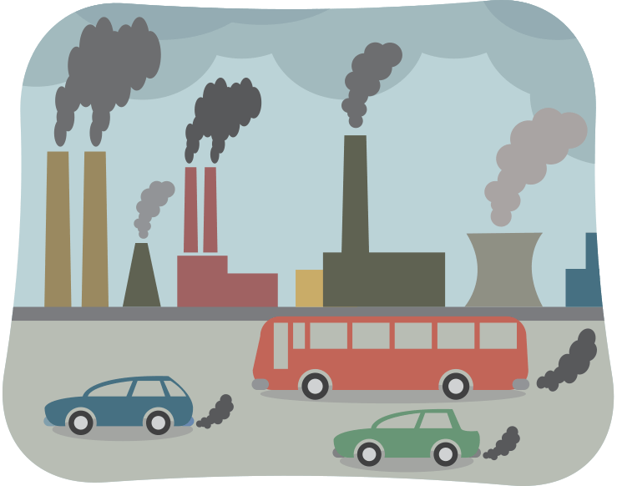
Outdoor Air Pollutants
1) List ALL the air pollutants emitted from burning coal.
2) Nitrogen oxides are primary air pollutants. However, they can mix with other compounds in the air to make photochemical smog and acid rain. Smog and acid rain are examples of what type of pollutants?
3) The burning of diesel fuel releases what type of outdoor air pollutant?

Photochemical Smog
4) In the box below, write a series of chemical reactions that leads to the formation of tropospheric ozone in photochemical smog.

5) What is a VOC? What are their main sources?
6) In what seasons do we see increases in smog concentration? Why?
7) Why are there high levels of smog in urban areas?
Thermal Inversion
8) In the two boxes below, draw what normal conditions in the atmosphere look like. Then draw what thermal inversion conditions look like in the atmosphere.
Normal Conditions | Thermal Inversion Conditions

9) Why do thermal inversion layers trap pollutants?
Particulate Matter
8) What are natural sources of particulate matter in the air?
9) What’s the difference between PM 2.5 and PM 10?
Carbon Dioxide
10) What are some natural sources of carbon dioxide in the atmosphere?
Indoor Air Pollutants
11) Identify significant sources of the following indoor air pollutants:
a) Formaldehyde:
b) Radon:
c) Mercury:
d) Lead
e) Carbon monoxide:
f) VOC’s:
g) Asbestos:
12) List three specific health effects of lead on humans.
13) What is Sick Building Syndrome?
Reduction of Air Pollutants
14) Define:
a) Baghouse filter:
b) Electrostatic precipitator:
15) What is a wet scrubber and how does it work? What is a dry scrubber and how does it work?
16) What is a vapor recovery nozzle on gas pumps?
17) What are the three things that a catalytic converter does on an automobile?
18) What does the Clean Air Act of 1970 mandate? What are NAAQS? Why were they created?
Acid Rain
19) For each of the following substances, draw an arrow that points to an unambiguous location along the line, below, representing pH: orange juice; normal rain; ammonia; lime (calcium carbonate); sulfuric acid; acid rain; human blood.

- 2 3 4 5 6 7 8 9 10 11 12 13 14

20) In the box below, write a series of chemical reactions that leads to the formation of acid rain from sulfur oxides and nitrous oxides.
Sulfur Oxides | Nitrous Oxides

21) In the box below, write the chemical equation for the formation of carbonic acid from the reaction of water with carbon dioxide.

22) Identify two places in the environment where the above reaction occurs naturally.
23) What are some environmental consequences of acid rain/deposition?
24) How can limestone neutralize acid rain?

Noise Pollution
23) How does noise pollution affect human health?
24) What are sources of noise pollution?
25) How does noise pollution affect organisms in the environment?

Sample FRQ’s
26) In recent years, results from scientific studies have increased public awareness of the possible damage to human health from exposure to indoor air pollution.
(a) Identify two specific indoor air pollutants and, for each, discuss the following.
(i) The type of building most affected by the pollutant
(ii) Source(s) of the pollutant
(iii) The pollutant’s effects on human health
(iv) The method(s) of prevention or cleanup of the pollutant
(b) According to the Environmental Protection Agency, at least 17 percent of the four million commercial buildings in the United States can be considered sick buildings.
(i) Explain what is meant by the term sick building.
(ii) Describe the criteria used for determining whether a building is sick.
27) Electric vehicles often have been proposed as an environmentally sound alternative to the gasoline engine for transportation. In response to state initiatives, several car manufacturers now include electric vehicles among their available models. In spite of these state initiatives, the penetration of electric vehicles into the transportation sector of the United States, as well as other countries, remains modest.
(a) Identify and describe two environmental benefits to using electric vehicles in place of gasoline-powered engines for transportation.
(b) Estimate the potential reduction in petroleum consumption (in gallons of gasoline per year) that could be achieved in the United States by introducing electric vehicles under the following assumptions:
1. The mileage rate for the average car is 25 miles per gallon of gasoline.
2. The average car is driven 10,000 miles per year.
3. The United States has 150 million cars.
4. 10 percent of United States cars could be replaced with electric vehicles.
(c) Some people have suggested that electric vehicles only shift the emission of air pollutants from dispersed sources to point sources. Explain and defend or refute this statement.
(d) Propose two potential new United States government policies that would encourage the widespread use of electric vehicles. Explain.

Modified by A. Willis from David Hong’s AP Environmental Science Review Packets (Diamond Bar HS), 2020. FRQ’s are College Board Released.
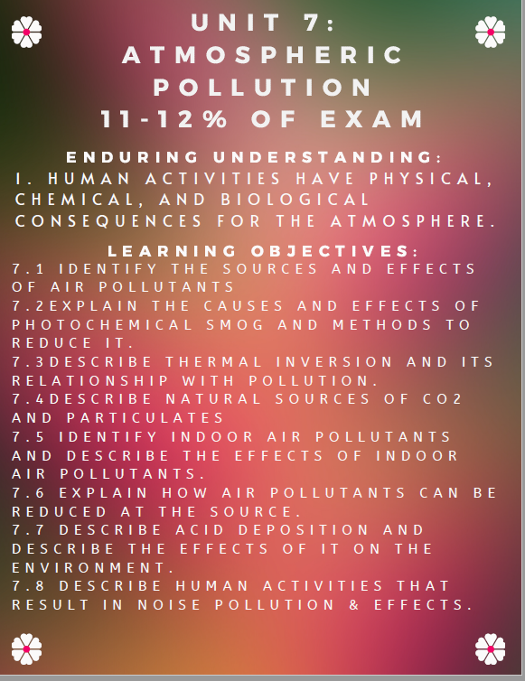
Unit 7 Atmospheric Pollution Review Videos
Mr. Andersen, Bozeman Biology
029 - Air Pollution
032 - Health Impacts of Pollution

Ted Ed
The Science of Smog: https://www.youtube.com/watch?v=CdbBwIgq4rs
US National Library of Medicine
Something in the Air: PM and Health: https://www.youtube.com/watch?v=zrHmD94F95A
BrainStuff
https://www.youtube.com/watch?v=mmho_iKsfQo
Sci Show
If There’s Acid Rain, Is There Basic Rain? https://www.youtube.com/watch?v=onq8u1W9QbA
National Geographic
Air Pollution 101: https://www.youtube.com/watch?v=e6rglsLy1Ys
What is Acid Rain: https://www.youtube.com/watch?v=1PDjVDIrFec
Fuse School
Acid Rain: https://www.youtube.com/watch?v=Nf8cuvl62Vc
Khan Academy
Asbestosis: https://www.youtube.com/watch?v=w1_EEi8-EaI

Barron’s Review Chapters, 7th Edition
Chapter 9: Pollution (Page 301)

Unit 7 Atmospheric Pollution Vocabulary
Air quality advisories - These advisories are usually called when the Air Quality Index (or AQI) gets into the unhealthy ranges. Different air pollution control agencies call them at different levels.
Air Quality Index (AQI) - A nationally uniform index for reporting and forecasting daily air quality. It is used to report on the four most common ambient air pollutants that are regulated under the Clean Air Act: ground-level ozone, particle pollution (PM₁₀ and PM_{2.5}), carbon monoxide (CO), and sulfur dioxide (SO₂). The AQI focuses on health effects that may be experienced within a few hours or days after breathing polluted air.
Carbon monoxide (CO) - A colorless, odorless gas that can be harmful when inhaled in large amounts. CO is released when something is burned. The greatest sources of CO to outdoor air are cars, trucks, and other vehicles or machinery that burn fossil fuels.
Coarse particles (also known as PM_{10-2.5}) - Particles with diameters generally larger than 2.5 micrometers (µm) and smaller than, or equal to, 10 µm in diameter.
Fine particles (also known as PM_{2.5}) - Particles that are generally 2.5 µm in diameter or smaller. This group of particles also encompasses ultrafine particles and nanoparticles which are generally classified as having diameters less than 0.1 µm.
HEPA (high-efficiency particulate air) filter - A type of pleated mechanical air filter. It is an acronym for "high-efficiency particulate air [filter]" (as officially defined by the U.S. Dept. of Energy). This type of air filter can theoretically remove at least 99.97% of dust, pollen, mold, bacteria, and any airborne particles with a size of 0.3 microns (µm).
Inversion - An atmospheric condition where a layer of cooler air is trapped near the ground by a layer of warmer air above. When the air cannot rise, pollution at the surface also is trapped and can accumulate, leading to higher concentrations of ozone and particle pollution.
National Ambient Air Quality Standard (NAAQS) - The Clean Air Act requires EPA to set National Ambient Air Quality Standards for pollutants considered harmful to public health and the environment. The EPA has set National Ambient Air Quality Standards for six criteria pollutants: sulfur dioxide (S0₂), particulates (PM_{2.5}/PM₁₀), nitrogen oxides (NO_{x}), carbon monoxide (CO), ozone (O₃), and lead (Pb). Periodically, the standards are reviewed and may be revised.
Older adults - In many studies, older adults are defined as ages 65 years and older due to age definitions provided in health datasets such as the Medicare database. In terms of increased risk from air pollution, there is not a specific age at which someone is considered “older” because people age at different rates. As a person ages, there is greater susceptibility to environmental hazards due to a number of factors, including higher prevalence of pre-existing respiratory and cardiovascular disease, as well as the gradual decline in physiological defenses that occur as part of the aging process.
Tropospheric of Ground Level Ozone - Ground level ozone is not emitted directly into the air, but is created by chemical reactions between oxides of nitrogen (NOx) and volatile organic compounds (VOC). This happens when pollutants emitted by cars, power plants, industrial boilers, refineries, chemical plants, and other sources chemically react in the presence of sunlight. Ozone at ground level is a harmful air pollutant, because of its effects on people and the environment, and it is the main ingredient in “smog."
Particle pollution (also known as particulate matter or PM) - General term for a mixture of solids and liquid droplets suspended in the air.
Sensitive groups (also called at-risk populations) - A term used for a category of persons at increased risk of experiencing adverse health effects related to air pollution exposures. These groups can be at increased risk due to intrinsic factors (biological), extrinsic factors (external, non-biological), higher exposure, and/or increased dose at a given concentration. The severity of the health effects that these groups experience may be much greater than in the general population.
Sulfur dioxide (SO₂) - One of a group of gases called sulfur oxides (SO_{x}). While all of these gases are harmful to human health and the environment, SO₂ is of greater concern. The largest sources of SO₂ emissions are from fossil fuel combustion at power plants and other industrial facilities.
Ultrafine particles (also known as PM_{0.01}) - Particles that are generally classified as having diameters less than 0.1 µm.

